Revised 2019
Kentucky Department of Fish & Wildlife Resources
SPECIAL COMMISSION PERMITS
Application Form

Organizations must provide this information even if an application was completed in previous years. Please fill out every blank. If the item is not applicable to your organization, please enter “N/A” as the response. Incomplete applications will not be considered. The application must be postmarked or delivered to the department by MAY 1.

- ORGANIZATION INFORMATION
Organization:
Address:
Contact Person: Telephone #:
Email Address:

- PERMITS
Please mark (X) the permit(s) requested:
SPRING TURKEY: FALL/WINTER DEER:
FALL ELK: FALL/WINTER WATERFOWL:
Method of transferring permits to individual (Auction, Raffle, etc.):

- PROCEEDS
Estimated dollar amount to be raised:
Rationale for this estimate:

- FUND-RAISING HISTORY
List past examples of fundraising, including money raised, and any other methods used that demonstrate fundraising ability:

- PRIOR EXPERIENCE WITH CONSERVATION PROJECTS
List past experience with natural resource conservation projects that have enhanced fish and wildlife resources to provide opportunities for hunting, fishing, trapping, wildlife education, habitat enhancement, or related activities, such as shooting sports, hunter and angler education and training, boating, etc. Please include years of such experience:

- PROPOSED PROJECT
Proposed wildlife conservation project(s) for which proceeds will be used:
Who will the proposed project primarily benefit? (Available to all members of the public, benefits a class of members of the public, benefits members of a private organization, benefits individual landowners, etc.) Please be specific.

Will the project funds be used to purchase tangible goods that are not expended during the project? (Electronics, vehicles, trailers, hunting or fishing equipment, etc.)

If the project funds will be used to purchase tangible goods that are not expended during the project, who will maintain ownership of those goods? Please be specific.

- THE PROPOSED PROJECT’S POTENTIAL FOR ENHANCING FISH AND WILDLIFE, HABITATS, FISH AND WILDLIFE EDUCATION, OR FISH AND WILDLIFE-RELATED RECREATION IN KENTUCKY
Please explain how your proposed project will support one or more of the above categories:

H) PER THE REQUIREMENTS OF 301 KAR 3:100, PLEASE ATTACH:
- One copy of your organization’s Articles of Incorporation.
- One copy of your organization’s bylaws that state the purposes of the organization, if the purposes of the organization are not stated in the articles of incorporation.
3. A copy of the most recent Internal Revenue Service determination letter establishing your organization’s current tax exempt status and your organization’s Employer Identification Number (EIN).
4. If your organization is an affiliated, state, or local chapter of a parent organization, a letter, dated within 90 days of the application, from your organization’s parent organization that states your chapter is in good-standing and is recognized by the parent organization.

I) SIGNATURE
I attest that the provided information is truthful and accurate and agree to comply with the requirements of KRS Chapter 150 and 301 KAR 3:100.

_________________________________________________ ________________________
Authorized Officer of Conservation Organization DATE
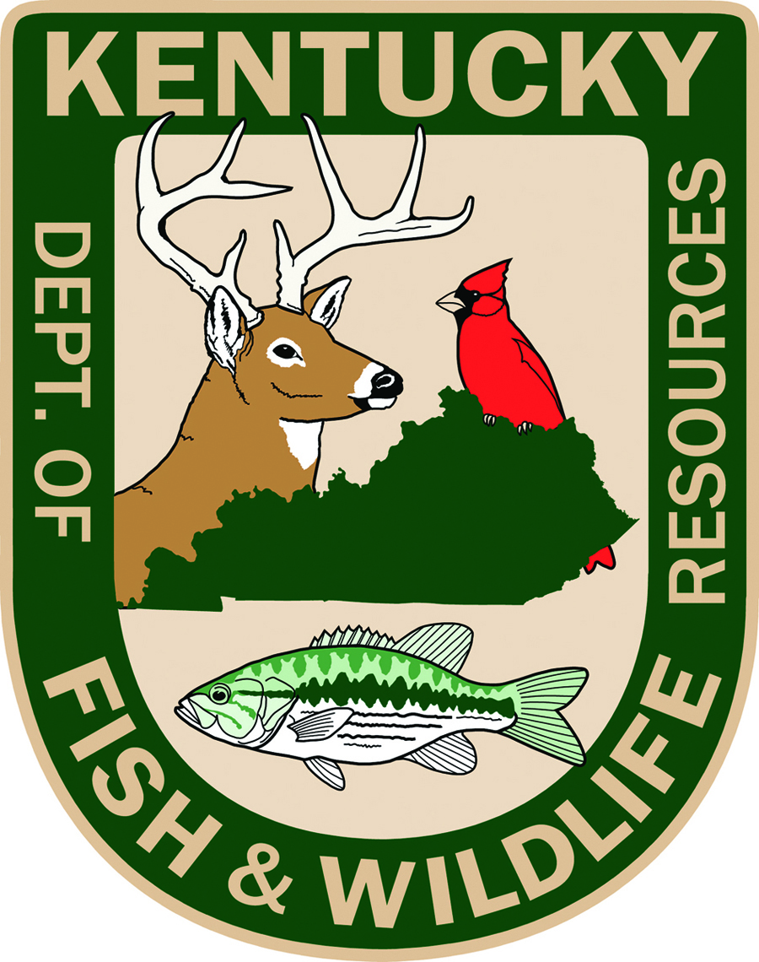
SEND COMPLETED APPLICATION AND ACCOMPANYING DOCUMENTS TO:
Kentucky Department of Fish and Wildlife Resources
#1 Sportsman’s Lane
Frankfort, KY 40601
ATTENTION: Commission Permit Application

ALL MAIL MUST BE POSTMARKED OR DELIVERED BY MAY 1.

