**Revised 2015**

**Kentucky Department of Fish & Wildlife Resources**

**SPECIAL COMMISSION PERMITS**

**Application Form**

**Organizations must provide this information even if an application was completed in previous years.**

**Application must be postmarked by MAY 1. Permit to be awarded at the June Commission Mtg.**

1. **ORGANIZATION INFORMATION**

**Organization:** Click here to enter text.

**Address:** Click here to enter text.

**Contact Person:** Click here to enter text. **Telephone #:** Click here to enter text.

**Email Address:** Click here to enter text.

1. **PERMITS**

**Please mark (X) the permit(s) requested:**

**SPRING TURKEY:** Click here to enter text. **FALL/WINTER DEER:** Click here to enter text. **FALL ELK:** Click here to enter text. **FALL/WINTER WATERFOWL:** Click here to enter text.

**Method of transferring permits to individual (Auction, Raffle, etc.):** Click here to enter text.

1. **PROCEEDS**

**Estimated dollar amount to be raised:** Click here to enter text.

**Rationale for this estimate:** Click here to enter text.

1. **PROJECT**

**Proposed wildlife conservation project(s) for which proceeds will be used:** Click here to enter text.

1. **PAST COMMISSION PERMIT AWARDS**

**If you applied and were awarded a special permit in the past, please list the year & type of permit, net proceeds for each permit, and a summary of the conservation project(s) funded:** Click here to enter text.

1. **FUND-RAISING HISTORY**

**List past examples of fundraising, including the money raised, and any other methods used that demonstrate fundraising ability:** Click here to enter text.

1. **EXPERIENCE WITH CONSERVATION PROJECTS**

**List past experience with natural resource conservation projects that have enhanced fish and wildlife, habitats, fish and wildlife education, or fish and wildlife-related recreation. Please include years of such experience:** Click here to enter text.

1. **THE PROPOSED PROJECT’S POTENTIAL FOR ENHANCING FISH AND WILDLIFE, HABITATS, FISH AND WILDLIFE EDUCATION, OR FISH AND WILDLIFE-RELATED RECREATION IN KENTUCKY**

**Please explain how your proposed conservation project will support one or more of the above categories:** Click here to enter text.

1. **PER THE REQUIREMENTS OF 301 KAR 3:100, PLEASE ATTACH:**
2. **One copy of your organization’s Articles of Incorporation or Bylaws.**
3. **Written proof of your organization’s federal tax-exempt status including the individual tax ID number.**
4. **If applicable, a letter from your organization’s parent organization that states your chapter is in good-standing and is recognized by the parent organization.**

***Failure to disclose and attach the requested information will result in a disqualification from consideration.***

1. **SIGNATURE**

**I attest that the provided information is truthful and accurate and agree to comply with the requirements of KRS Chapter 150 and 301 KAR 3:100.**

**_________________________________________________ ________________________**

**Authorized Officer of Conservation Organization DATE**

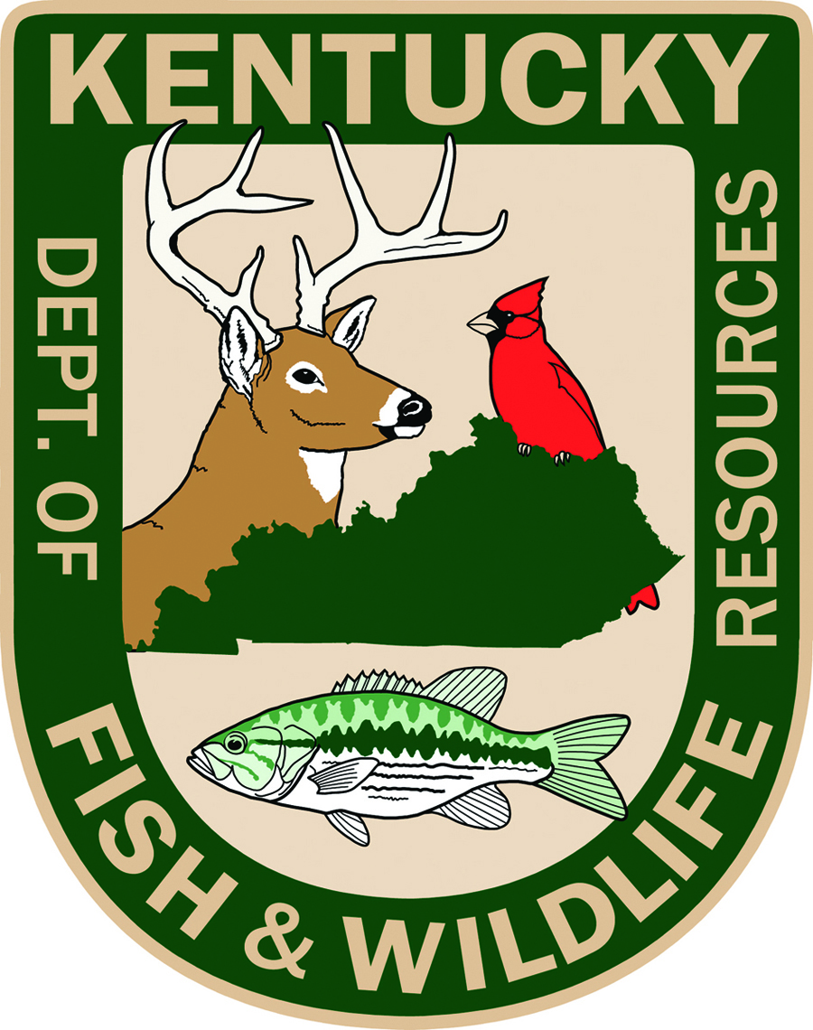

**SEND COMPLETED APPLICATION AND ACCOMPANYING DOCUMENTS TO:**

**Kentucky Department of Fish and Wildlife Resources**

**#1 Sportsman’s Lane**

**Frankfort, KY 40601**

**ATTENTION: Commission Permit Application**

**ALL MAIL MUST BE POSTMARKED BY MAY 1**